**ITI 200 Introduction to Cloud Computing**

**CITRPG**

**Team Members**

Laci Parker

Hamid Sutton

# 1. Problem

* The problem we want to solve is making a computer trivia game that is enjoyable for everyone.
* We want to have questions that are not too easy or too hard so beginners and experienced players can have fun playing and learning something new.
* We want to make the game interesting and inclusive for everyone.

# 2. Solution

* To build a trivia game is like putting a puzzle together. You have the following tools.
  + Javascript holds the game together to make everything functional.
  + HTML provides structure to the game's content.
  + CSS is about coloring and styling to make it more appealing.
  + Bootstrap handles the ultimate set of tools you need to ensure everything works.
* 
* 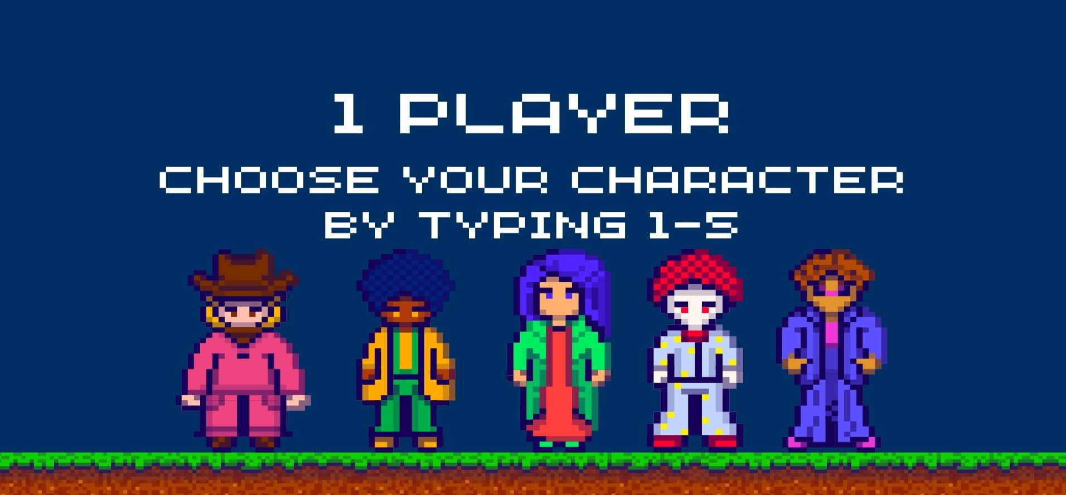
* 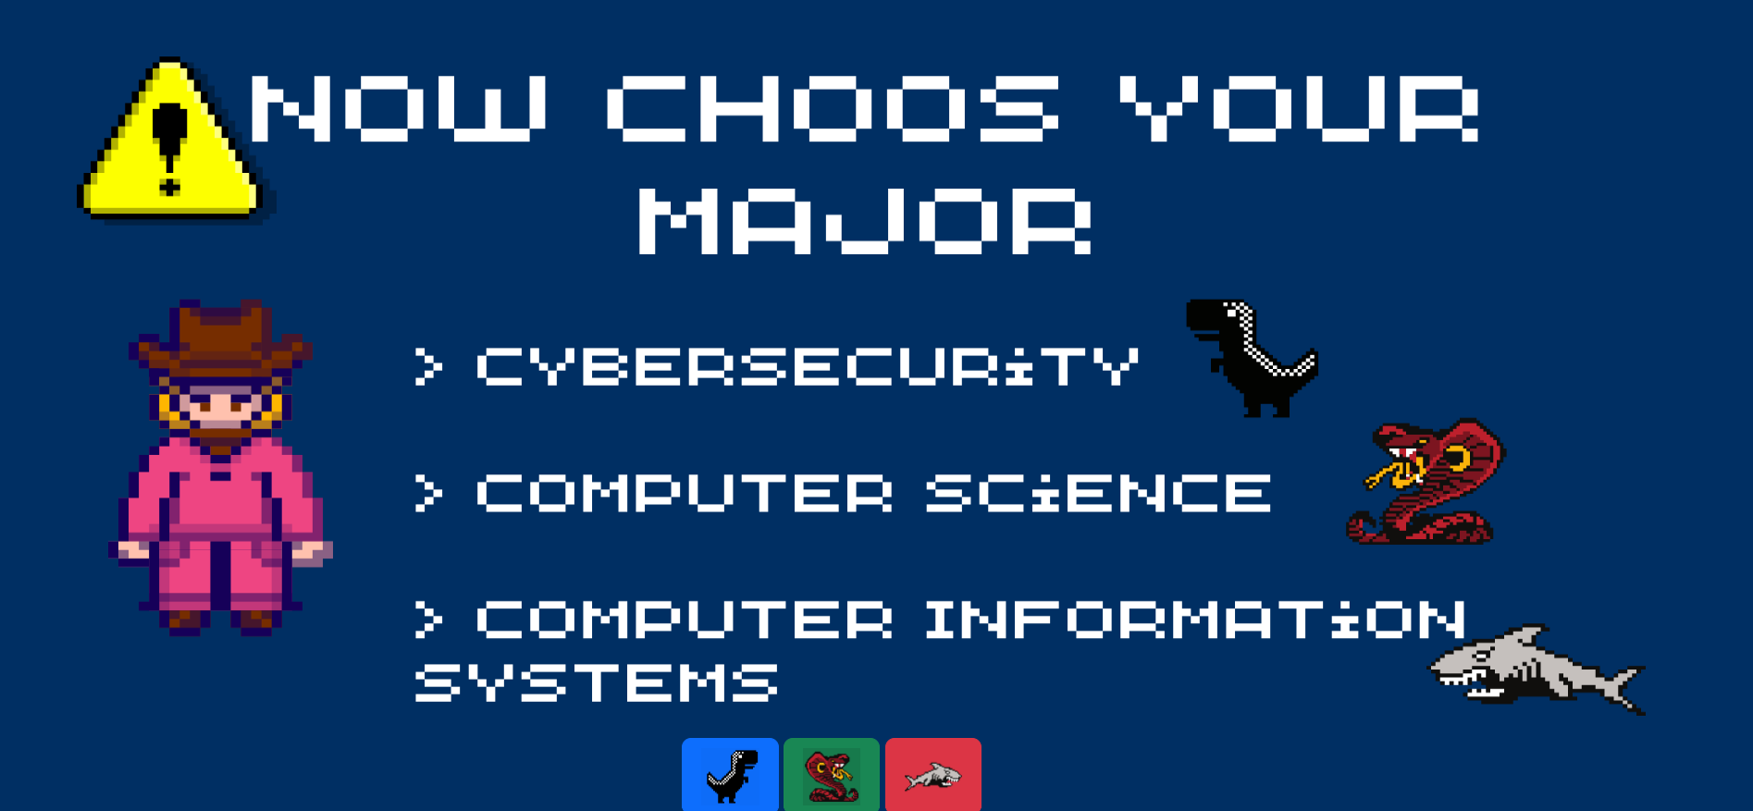

# 4. Lessons learned while developing the project

* Learning to know where certain codes go in place of HTML, CSS, Javascript, JQuery, and Bootstrap of a document.
* Looking through documentation to find resources to help further the development of the game.
* Learning to use Canva-created images to further the style process and to help preplan for the story of the game.
* Learning how to lay buttons over images

# 5. Issues/Bugs Known

* CSS styling issues. We had trouble running the document on web browsers and making changes to get it right.
* HTML structure errors. Improper nesting of HTML elements, missing or closing tags.
* Inputting codes in the wrong areas of the documents.
* When picking a character it will only let you choose one character
* Once in the game, there is no way to get out or go back unless exiting the entire thing

# 6. Future Versions

* A complete and functional trivia game for everyone to enjoy from selecting characters to levels of difficulty.

# 7. References

* <https://getbootstrap.com/docs/5.2/content/typography/>
* <https://getbootstrap.com/>
* <https://www.w3schools.com/js/default.asp>
* <https://www.w3schools.com/js/js_jquery_selectors.asp>
* <http://www.w3schools.com/jquery/default.asp>
* <http://www.w3schools.com/jquery/jquery_events.asp>
* <https://www.canva.com/>